
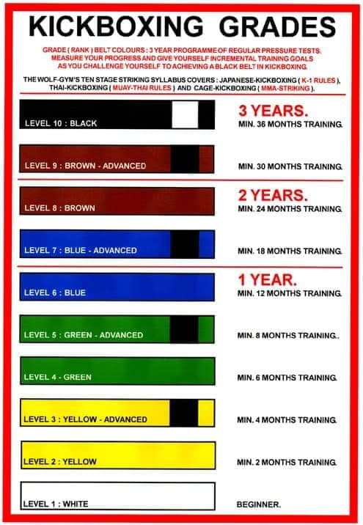
I wish to apply for my next Elite/Combudo MMA/Kickboxing Grading
Elite Grading costs $60.00 My Name is…………………. My Age is……………………and I have trained ……………. hours since my last grading.

I wish to apply for my next MTIA Muay Thai Grading
An MTIA fighters/grading record book cost $50 & is compulsory before you contest or grade. MTIA Grading Costs $110.00 and includes Prajiad’s & Thailand Certification. Sashes cost an additional $20. My Name is…………………. My Age is……………………and I have trained ……………. hours since my last grading.

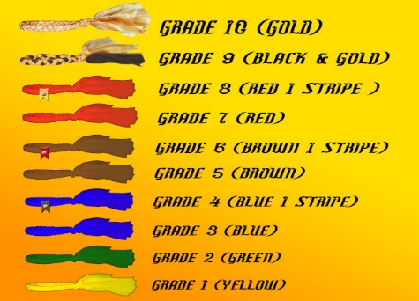 Grading fees must be paid in advance to Elite/ISKAMTIA BSB 302-162 Acc 1676575 email your forms to elitemma@outlook.com.au Total fees sent = ……………

